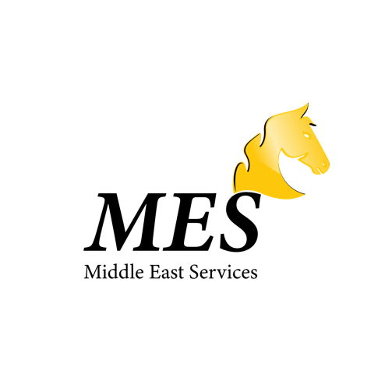

**Dr. Ahmad Smadi**

**Middle East Service SDN BHD**

**Seri Cendikia Condominium**

**Jalan 4/124, Taman Connaught, 56000 Cheras,**

**Wilayah Persekutuan Kuala Lumpur**

To Whom It May Concern:

Middle East Service (MES) has enrolled in a Malaysian educational provider to study at a university. Since we discovered our company Middle East Service (MES) enrolling in terms of education advisor for those who want to study in Malaysia, we would like to be a part of UNITEN as an agent. Since then, we've had a lot of opportunities in this area and would like to develop it even further. We will be proud to be a part of UNITEN, as the chances are much too numerous to be squandered.

**Product/Service**

* Educational advisor/provider
* Logistic
* Import and export
* Multimedia industry

**Market analysis**

* Wide in the middle east country for those who need to study in Malaysia.
* Enrolling in the logistics industry
* Import and export